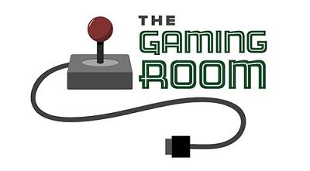

GamingRoomProject3

CS 230 Project Software Design Template
Version 3.0

Table of Contents

CS 230 Project Software Design Template 1
Table of Contents 2
Document Revision History 2
Executive Summary 3
Requirements 3
Design Constraints 3
System Architecture View 3
Domain Model 3
Evaluation 4
Recommendations 5

Document Revision History

Version | Date | Author | Comments
3.0 | 10/18/2025 | Crystal Adamson | Final submission

Instructions
Fill in all bracketed information on page one (the cover page), in the Document Revision History table, and below each header. Under each header, remove the bracketed prompt and write your own paragraph response covering the indicated information.

Executive Summary

Draw It or Lose It is a web-based drawing guessing game. It is designed to be a cross-platform, multiplayer event. Its design allows multiple clients from different platforms (desktop, mobile) to interact in a virtual team environment. All clients connect to a central server that manages the game (players, images, teams, and scores). The provided design implements user data security and maintainability.

Requirements

The game should maintain teams, players, and scores, provide communication between players for the ability to make guesses, and record the game data (player accounts, scores, history, etc).

Design Constraints

Latency—the cross-platform multiplayer game needs to ensure near real-time interactions.
Scalability—to host multiple games (for different teams) participating at the same time.
Cross-platform architecture—to work with all players from all platforms (web or mobile, mac or windows, etc.).
Memory limits—with a cross-platform architecture, differing platforms offer differing amounts of memory, so memory should be kept as minimal as possible.
Security—player data (personal information, scores, communication) needs protected through encryption and authorizations checks.

System Architecture View

Please note: There is nothing required here for these projects, but this section serves as a reminder that describing the system and subsystem architecture present in the application, including physical components or tiers, may be required for other projects. A logical topology of the communication and storage aspects is also necessary to understand the overall architecture and should be provided.

Domain Model

GameService—creates and retrieves Game, Team, and Player objects.

Game/Team/Player—create and retrieve the gameId/teamId/playerId, gameName/teamName/playerName and a list of Teams/Players, respectively.

Game has many Team objects.

Team has many Player objects.

GameService provides retrieval methods for these objects.

Encapsulation—fields are private and employ getters to control access to them.

Polymorphism—the ability to have many versions of the game, its teams, and the players, all created by the same process but having unique names (making them separate objects) shows that there can exist many forms of these objects.

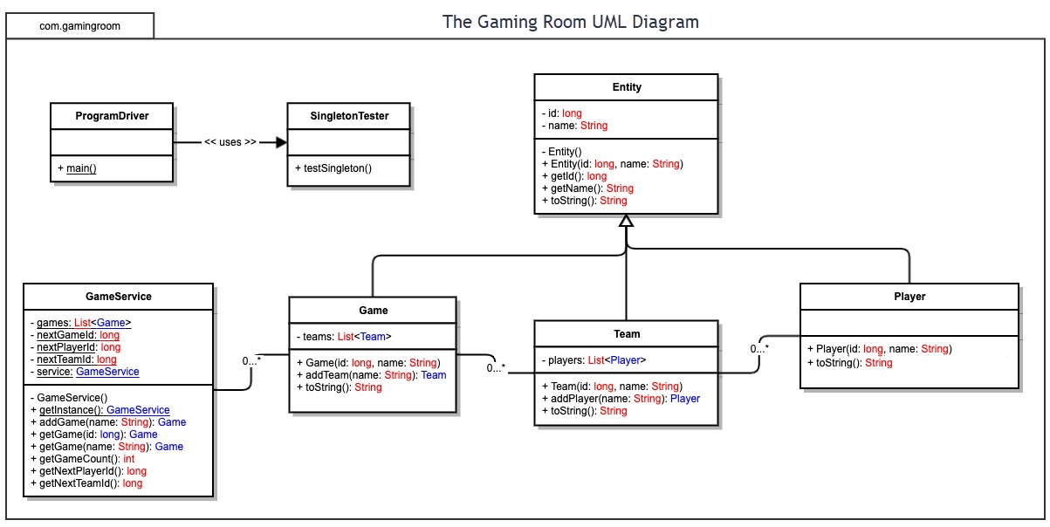

Evaluation

Using your experience to evaluate the characteristics, advantages, and weaknesses of each operating platform (Linux, Mac, and Windows) as well as mobile devices, consider the requirements outlined below and articulate your findings for each. As you complete the table, keep in mind your client’s requirements and look at the situation holistically, as it all has to work together.

In each cell, remove the bracketed prompt and write your own paragraph response covering the indicated information.

Development Requirements | Mac | Linux | Windows | Mobile Devices
Server Side | Good for development, testing and developer tools because it supports major server runtimes.  Disadvantaged for hosting collaborative production.  Server hosting:  macOS Server is effectively discontinued and, therefore, not a promising host. They will have much higher costs than other server options and much less support. | RECOMMENDED  Best choice for production—great container support, low overhead, strong cloud deployment.  Server hosting:  Hosting on Linux servers or cloud VMs (cloud virtual machines) will provide the lowest cost for a web-scaled, production-ready stack.  Potential cost:  Distributions are free for community use. However, if enterprise support or long-term security updates are needed, there are subscriptions (prices vary) for these services. | Good for Windows app services.  Disadvantaged for Linux applications.  Server hosting:  Windows Server is fully capable of hosting a web-scaled production-ready stack, but it usually carries a higher cost.  Potential cost:  The lowest seems to be $730 + Client Access Licenses (CALs)—you have to contact Microsoft for a comprehensive price quote based on your needs. | Not suitable as primary servers.  Server hosting:  Not practical for web-based production-ready stack hosting.
Client Side | Good for developing desktop and iOS.  Disadvantaged in terms of price, it generally has a higher cost to development use.  Production:  To produce a single web application that works across all targeted OSs:  1. Primary application is developed as a responsive HTML/JavaScript/CSS build as a Progressive Web App (PWA)—app-like installation on mobile OSs and still works on desktop browsers with a fast time-to-market build.  2. Use WebSockets for rendering drawings and game communication and RESTful API for login and scores.  3. Perform cross-browser compatibility testing to ensure seamless game play accessibility for all targeted OSs.  4. For an app store presence, wrap the application in a native wrapper—additional cost to host in the Apple App Store ($299/year) and Google Play Store ($25 one-time fee). | RECOMMENDED  Excellent for web-client development and testing and lower cost for development.  Disadvantaged for mobile development as some testing is possible, however macOS is required for iOS builds.  Production:  To produce a single web application that works across all targeted OSs:  1. Primary application is developed as a responsive HTML/JavaScript/CSS build as a Progressive Web App (PWA)—app-like installation on mobile OSs and still works on desktop browsers with a fast time-to-market build.  2. Use WebSockets for rendering drawings and game communication and RESTful API for login and scores.  3. Perform cross-browser compatibility testing to ensure seamless game play accessibility for all targeted OSs.  4. For an app store presence, wrap the application in a native wrapper—additional cost to host in the Apple App Store ($299/year) and Google Play Store ($25 one-time fee). | Good for developing Windows desktop applications. Android development is supported.  Disadvantaged for Mac development.  Production:  To produce a single web application that works across all targeted OSs:  1. Primary application is developed as a responsive HTML/JavaScript/CSS build as a Progressive Web App (PWA)—app-like installation on mobile OSs and still works on desktop browsers with a fast time-to-market build.  2. Use WebSockets for rendering drawings and game communication and RESTful API for login and scores.  3. Perform cross-browser compatibility testing to ensure seamless game play accessibility for all targeted OSs.  4. For an app store presence, wrap the application in a native wrapper—additional cost to host in the Apple App Store ($299/year) and Google Play Store ($25 one-time fee). | Not well suited because of memory constraints and minimal screen size.  Production:  To produce a single web application that works across all targeted OSs:  1. Primary application is developed as a responsive HTML/JavaScript/CSS build as a Progressive Web App (PWA)—app-like installation on mobile OSs and still works on desktop browsers with a fast time-to-market build.  2. Use WebSockets for rendering drawings and game communication and RESTful API for login and scores.  3. Perform cross-browser compatibility testing to ensure seamless game play accessibility for all targeted OSs.  4. For an app store presence, wrap the application in a native wrapper—additional cost to host in the Apple App Store ($299/year) and Google Play Store ($25 one-time fee).
Development Tools | IDEs—IntelliJ IDEA, VS Code, Xcode (iOS).  Languages—Java/Kotlin, JavaScript/TypeScript, Swift (iOS).  Multi-platform production build:  Many development tools are needed to perform the entire build-to-market. (Programming Languages/frameworks: JavaScript, TypeScript + React, Vue, Angular, HTML5 Canvas, SVG, etc. Tooling/IDEs: REST API, VS Code, etc. Testing: Cypress, Playwright, BrowserStack/device labs.) The engineers/designers working to build a responsive, immersive, amazing Draw It or Lose It app will know which tools they need to build an amazing product.  The full team would likely include:  1 or 2 Frontend engineers  1 or 2 Backend engineers  1 DevOps  1 QA/testing engineer  1 UX designer  1 iOS engineer  1 Android engineer | RECOMMENDED  IDEs—IntelliJ, VS Code.  Languages—Java, Node.js, Go, etc.  Recommended for backend deployments.  Multi-platform production build:  Many development tools are needed to perform the entire build-to-market. (Programming Languages/frameworks: JavaScript, TypeScript + React, Vue, Angular, HTML5 Canvas, SVG, etc. Tooling/IDEs: REST API, VS Code, etc. Testing: Cypress, Playwright, BrowserStack/device labs.) The engineers/designers working to build a responsive, immersive, amazing Draw It or Lose It app will know which tools they need to build an amazing product.  The full team would likely include:  1 or 2 Frontend engineers  1 or 2 Backend engineers  1 DevOps  1 QA/testing engineer  1 UX designer  1 iOS engineer  1 Android engineer | IDEs—IntelliJ, Visual Studio, VS Code.  Languages—Java, Node.js, Go, etc.  Recommended for .NET or desktop developments.  Multi-platform production build:  Many development tools are needed to perform the entire build-to-market. (Programming Languages/frameworks: JavaScript, TypeScript + React, Vue, Angular, HTML5 Canvas, SVG, etc. Tooling/IDEs: REST API, VS Code, etc. Testing: Cypress, Playwright, BrowserStack/device labs.) The engineers/designers working to build a responsive, immersive, amazing Draw It or Lose It app will know which tools they need to build an amazing product.  The full team would likely include:  1 or 2 Frontend engineers  1 or 2 Backend engineers  1 DevOps  1 QA/testing engineer  1 UX designer  1 iOS engineer  1 Android engineer | Toolchain—Android Studio (Android), Xcode (iOS).  Frameworks—React Native, Flutter (cross-platform clientele).  Multi-platform production build:  Many development tools are needed to perform the entire build-to-market. (Programming Languages/frameworks: JavaScript, TypeScript + React, Vue, Angular, HTML5 Canvas, SVG, etc. Tooling/IDEs: REST API, VS Code, etc. Testing: Cypress, Playwright, BrowserStack/device labs.) The engineers/designers working to build a responsive, immersive, amazing Draw It or Lose It app will know which tools they need to build an amazing product.  The full team would likely include:  1 or 2 Frontend engineers  1 or 2 Backend engineers  1 DevOps  1 QA/testing engineer  1 UX designer  1 iOS engineer  1 Android engineer

Recommendations

Analyze the characteristics of and techniques specific to various systems architectures and make a recommendation to The Gaming Room. Specifically, address the following:

- Operating Platform: I would recommend using Linux as the operating platform (server) for developing and cloud-deploying Draw It or Lose It.
Rationale: Linux offers strong stability, excellent security, and high performance for web-based, real-time applications. It supports modern containerization and orchestration tools, which will simplify scaling and maintenance as the game expands. Cloud providers (such as AWS, Azure, and Google Cloud) offer managed Linux environments at a lower cost than Windows or macOS servers.

Recommended Setup
Development: Ubuntu LTS or Debian-based VMs or containers for testing.
Production: Ubuntu LTS, Rocky Linux, or a managed Linux distribution hosted in the cloud.
Deployment option: A containerized application (e.g., Docker) that is managed by a cloud-hosted Kubernetes service (e.g., AWS EKS, GCP GKE, Azure AKS) to simplify scalability and ensure reliability.

- Operating Systems Architectures: I recommend the Linux platform because it uses a multi-tier, service-oriented architecture.
Edge Layer: Would deliver drawings and user code through a global content delivery network (CDN) for high availability and low latency.
API Gateway and Load Balancer: Which would route incoming HTTPS and WebSocket traffic to backend services, ensuring the user’s connections (whether desktop, web or mobile) are properly distributed to the correct game server instance.
Game and Application Services: Real-time game servers will handle player connections, gameplay, and real-time drawing updates through WebSockets. REST API services will manage user accounts, teams, and leaderboards.
Data Layer: For persistent structured data it will use a PostgreSQL database. Redis cache for fast access to temporary game instance data. It has object storage for the game’s drawing images.
Orchestration and monitoring: It manages deployment, scaling, and service updates through the Kubernetes service. It also has centralized logging and monitoring (via tools) to ensure performance tracking and system health.
The Linux architecture provides a flexible, distributed environment capable of supporting thousands of concurrent players while maintaining performance and reliability.

- Storage Management: I would recommend using a PostgreSQL to store the permanent user data and an in-memory database (e.g., Redis) for temporary game data storage. I would recommend an object storage service (e.g., AWS S3 or Google Cloud Storage) to host the drawing library for Draw It or Lose It because they offer scalable distribution for the varying platforms the game will be delivered on.

- Memory Management: I would recommend storing temporary memory within the unit, but keep as much as possible on the server to improve access speed for all users of the cross-platform teams. Linux uses virtual memory and demand paging, allowing efficient sharing of physical memory between processes. It also uses caching intelligently, speeding up access to frequently used data while maintaining system stability, all while under load.
For Draw It or Lose It, this would mean that the minimal (current round, player connections, drawing buffer) would be the only things kept in RAM. Frequently accessed images would be cached in Redis to reduce latency with image library queries. PostgreSQL will periodically write game data to the database to prevent data loss in the event of a user’s system failing.

- Distributed Systems and Networks: I would recommend using WebSockets or message brokers so all instances can receive real-time communication quickly within the game. Using RESTful APIs can manage user authentication, data retrieval, and non-synchronized game tasks.

- Security: I would recommend using HTTPS/TLS for all communication. OAuth 2.0 for secure logins and ensure tokens are short-lived and refreshed securely. Encrypt all resting data (e.g., databases, backups, object storage). Store credentials and keys in a secure “secrets” manager. Maintain logs for all login attempts, administrative changes, and gameplay actions. Use firewalls to filter malicious traffic and prevent DDoS attacks. I recommend regular security audits, scans for vulnerabilities, and penetration testing to maintain a secure environment.

